Times New Roman; Size-16; Line Spacing: fixed-20pt; Paragraph Spacing: Above paragraph-10pt, Below paragraph-10pt
( do not insert the authors` names at all )

Abstract
To avoid introduction and generalities directly to the understudied issues and purposes is necessary in abstract, then methodology and the conclusions of the research should be shortly mentioned. The abstract of the paper with Times New Roman 9 and single space, 4.5 cm from right and 4.5 cm from left are considered as margins and arranged corners ( justify low ) . The abstract should be less than 120 words and more than 175, abstract is only one paragraph and please do not mention the references and footnotes.
Keywords: minimum 3 and maximum 5 words which are separated by coma should be in alphabetical order in one line , English font (Times New Roman; Size-10 )
Introduction (Times New Roman; Size-14)
It is necessary to type all the papers with the same scheme, thorough and coordinated to provide easy computerized files and send email to homogenize the papers altogether. This guideline helps authors to prepare their papers based on the accepted format of university. Please take the apparent format of this guideline and its writing based on accepted publications office of Management Faculty.
The typesetting of paper is done by considering 4.5 cm margin in sides, 5.35 cm upper and lower spacing in A4 with space line of 1 cm.
Main context of the paper should be written in a single- column format, English font Times New Roman 11 single space.
The order of paper titles (very important)
The order of paper titles exactly includes introduction, background, research, methodology, research findings, conclusion , suggestions and resources.
Note 1: To explain problem, purposes and the necessities of research should be mentioned in introduction. (In introduction it should be said: what is this research and why is it done?)
Note 2: following items should be mentioned in background of the paper.
- Theoretical background ( theories, views, approaches in this field )
- Experimental background ( their methodologies and previous researches )
- 3-conceptual model ( in case of research quantity and modeling )
Note 3: please avoid using words such as appendix, attachment and questionnaire in compiling an paper.Purposes, questions and the assumptions of the research should be explained at the end.
Submitted versions to publication office by the system of papers submission
Two, only two files are received. Main file of the paper (without the name of the authors ) and the file of authors` personal information with mentioned format by paper submission system.
Maximum pages of the paper
Maximum number of the pages ( including all parts of the paper such as abstract, resources , etc ) is determined by compilation guideline. It should not be more than 20 pages in this format.
Footnotes
If it is necessary to cite something in footnote, all English subtitles written on the font Times New Roman size 9 pt.

Introducing symbol s and variables in text
Any variables or applied symbols should be defined in first reference in text of paper.
Figures
Any figure such as chart , map etc..should have number and definition. None of these items has individual number but like middle align. should be typed and marked from 1 in order. Diagrams can be black and white or colorful, but should be recognized in a black and white print as well as details. Diagrams and figures are inserted in the text in which they are referred. To define the unit of quantities is essential. All diagrams should be referred to in the text of paper. To provide diagrams, pay attention to numbers, terms, quantities and curve guidelines ( legend ) to be big enough for being legible and clear after written in paper. Be careful if the figure in the paper is like an image ( software outlet ) it should be clarified .
It is logical to put the main file of diagrams in the paper. Consider one line space before and after each diagram one space from previous text. A sample diagram can be seen here. ( notice the diagram themselves should be inserted in middle align toward two sides of the paper.)
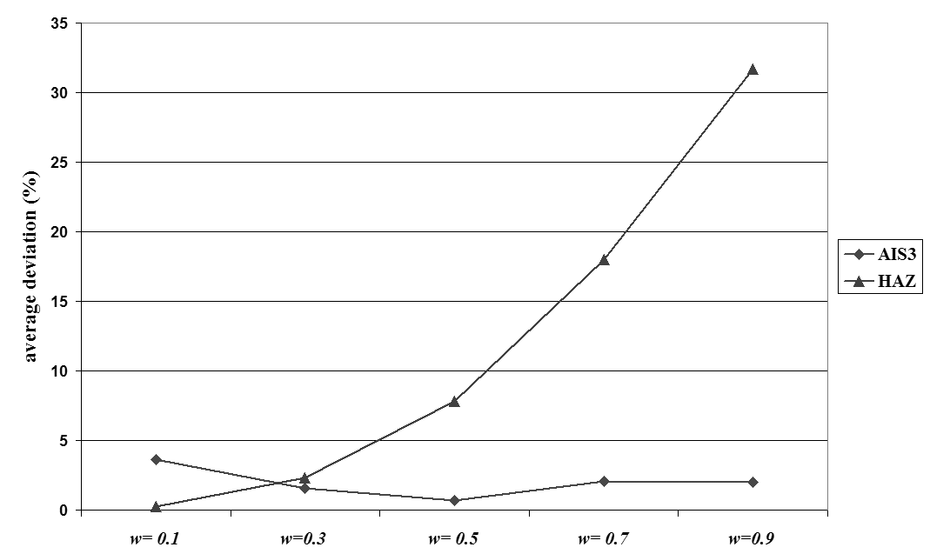
Figure 1. a sample diagram

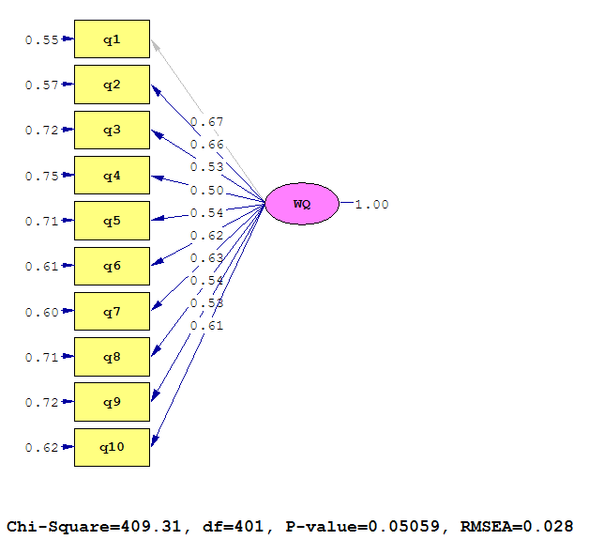
Figure 2. Model of studying relevant elements with website quality ( second sample )
Tables
Each table should have number and title ( definition ) which is written in the middle of tablet font Times new roman bold and size 10 pt. marking from 1 in order. Tables should be inserted inside the text after the space where they are mentioned.
The titles of the columns in tables should be written in middle align ( bold Times New Roman 10 pt) . All contexts in the table is written on the left in Latin ( Times New Roman 8 pt. )
All numbers should be typed in english in middle align. To write the unit of quantities are obligatory. Each table is inserted with one line space before and after the text. If tables have been extracted from a reference, the reference number should be inserted at the bottom of the table by a method called APA ( this method will be defined ).Table 1 has been drawn based on above guideline.

Table 1. A sample of table
 | The average number of disconnected node | Time average  Solving time ( second ) | Number of optimum solved samples |  | The size of the problem
Dominance  principle 1 | Low level |  | Method 2 | Method 1
1/00 | 94/29 | 0/00 | 15 | 20 | 5
1/05 | 87/52 | 0/00 | 14 | 20 | 10
1/07 | 87/64 | 0/01 | 12 | 19 | 15
2/20 | 90/60 | 0/11 | 9 | 19 | 20
2/51 | 91/03 | 1/39 | 10 | 14 | 25
2/32 | 92/19 | 32/20 | 8 | 10 | 30
3/36 | 93/34 | 613/30 | 8 | 10 | 35

Mathematical relations and Formulae
To display mathematical relations and formulae , please apply these two columns with invisible lines based on the sample below. In the right column of this table, relation number and in the left relation the relevant formulae is written. ( using Microsoft Equation is essential in writing formulae ) .
In case formulae are written in word setting version 2007, the submitted file should be saved with suffix docx to prevent formulae from changing to image .
All mathematical relations are marked from one respectively and number of relations are separated by parenthesis. Relations should be written font Times New Roman size 11 . Two formulae samples are below:
Relation 1 ) E =mc²
Relation 2 ) Sin 2ɵ = 2sin ɵ cos ɵ

Conclusion and suggestions
Conclusion is essential after main context of the paper. For any suggestions, you can write them in conclusion.
Method of sources
Use APA standard method for resourcing. It is better to apply Microsoft office or Endnote.
Important point about applicable sources: in table 2 , giving sources method to books and papers have been described. In case of using other information sources such as thesis, dissertation , research report ,the statistics of state organizations, unpublished pamphlets, internet websites, visual and audio files ..use APA sheets. All items which can be observed in table 2 should be considered. ( publication issue inside parenthesis , name of publication or thesis, title of the book in italic . ) you can get sheets file from here:
Note 1 :sources should be written completely . in English and Persian publications name of publication ( in italic ) respectively, course, ( publication issue inside parenthesis ), last page of paper , hyphen in the first paper of paper ( please see table 2 )
Note 2 : the sources relevant to books either Persian or English , the publishing and place of publishing should be written respectively. ( see table 3 )
Note 3 : the sources which are related to thesis or dissertation either English or Persian whose relevant university and city should be written. ( see table 3 )
Note 4 : in connection with the sources relevant to conferences, seminars, writing exact date and place of conference is essential.
Pay attention to translate Persian sources in English in source list ( please visit main sources or ask translator. Google translate won`t answer you correctly ). After translating the sources, all sources are arranged in English. At the end of Persian sources which translated to English definitely add ( in Persian ) definitely. It is worth mentioning that do not apply the words others or colleagues inside the context and cite the name of all authors and researchers unless they are more than 5 people.

Table 2. Accurate definition of sources inside the paper at the end
In source list | Inside context | Type of source
(Surname of first author, first letter of the first name of that author and surname of second author, first letter of the name of that author. ( publishing year )  Title of the paper, publication name, course ( issue ) last page of paper- first page of the paper. | (Sur name of first author and sure name of all authors, year) | Persian and English Paper
Moghimi, M. &AlaeiArdakani, M. (2011). Measuring good goverance factors and e-government role in enhancing it. Quarterly Journal of Information technology management, 3(8):  , 19 (4): 171–188. (in persian) | ( Moghimi, AlaeiArdakani, M. (2011). | Persian paper sample
Cordella, A. &Iannacci, F. (2010). Information systems in the public sector: The e-Government enactment framework. Journal of Strategic Information Systems, 19 (4): 52–66. | Cordella, A. &Iannacci, F. (2010) | English paper sample
(Surname of first author, first letter of the first name of that author and surname of second author, first letter of the name of that author. ( publishing year )  Title of the book, city, publisher | Surname of first author and surname of other authors, year, issue, page number or pages ) | English and Persian book
SeyedJavadein, S. R. (2004). Fundamentals of human resources management. Tehran, University of Tehran press (UTP). (in persian) | SeyedJavadein, S. R. (2004). | Persian book sample
Diaz-Rico, L. T. (2008). A course for teaching English learners. Boston, MA: Pearson | ( Hermen 144, 2010 ) | English book sample

Some important editing points
- Use numbers and points for marking; like marking in this part.
- During using parenthesis before and after opening and closing parenthesis, use space. The word inside parenthesis sticks to it without space.
- instead of using the sign ( % ) in context , use the word percent like 5 percent

Footnote ( Times New Roman 9 )

